Exercise 3: Assertions in JUnit (JUnit 5)

Objective
To understand and use common JUnit assertions such as assertEquals(), assertTrue(), assertFalse(), assertNull(), and assertNotNull() in a JUnit 5 test class. This exercise demonstrates how different JUnit assertions can be used to validate expected results while testing a Java application. The project was implemented using Visual Studio Code, Maven, and JUnit 5.

Software and Tools Used
- Visual Studio Code
- Java JDK 17
- Apache Maven
- JUnit 5 (JUnit Jupiter 5.10.2)

Implementation Steps
- Created a new Maven project named 'assertions'.
- Configured the pom.xml file with the JUnit 5 dependency and Maven Surefire Plugin.
- Created the package com.example under src/test/java.
- Created the AssertionsTest.java class.
- Implemented different JUnit assertions to verify expected conditions.
- Executed the test successfully using Maven/VS Code.

Implementation:
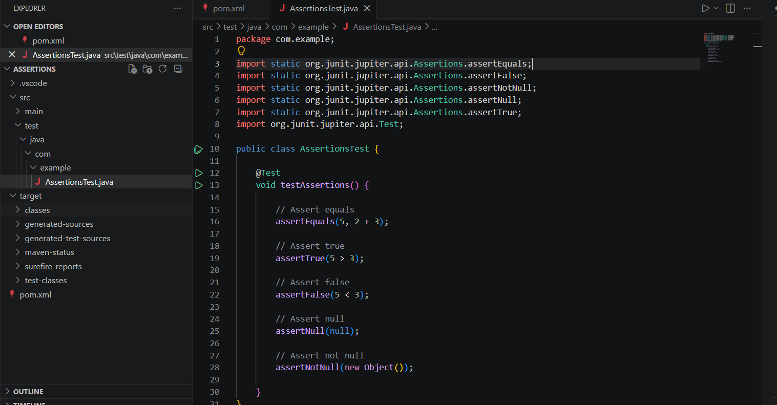

AssertionsTest.java
package com.example;
import static org.junit.jupiter.api.Assertions.*;
import org.junit.jupiter.api.Test;
public class AssertionsTest {
@Test
void testAssertions() {
// Assert equals
assertEquals(5, 2 + 3);
// Assert true
assertTrue(5 > 3);
// Assert false
assertFalse(5 < 3);
// Assert null
assertNull(null);
// Assert not null
assertNotNull(new Object());
}
}

Expected Output
Tests run: 1
Failures: 0
Errors: 0
Skipped: 0
BUILD SUCCESS
